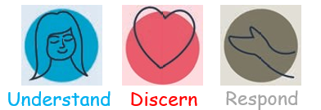
Year 2 RE Knowledge Organiser
Branch 1 – Creation and Covenant
Hear, Believe, Celebrate, Live | Vocabulary
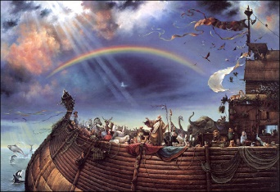  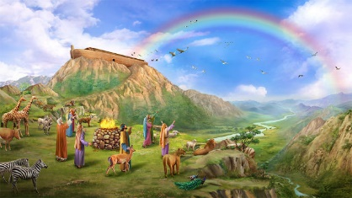  Genesis 9:7-17  ⁷And you, be fruitful and multiply, increase greatly on the earth and multiply in it.”  ⁸ Then God said to Noah and to his sons with him, ⁹ “Behold, I establish my covenant with you and your offspring after you, ¹⁰ and with every living creature that is with you, the birds, the livestock, and every beast of the earth with you, as many as came out of the ark; it is for every beast of the earth. ¹¹ I establish my covenant with you, that never again shall all flesh be cut off by the waters of the flood, and never again shall there be a flood to destroy the earth.” ¹² And God said, This is the sign of the covenant that I make between me and you and every living creature that is with you, for all future generations: ¹³ I have set my bow in the cloud, and it shall be a sign of the covenant between me and the earth. ¹⁴ When I bring clouds over the earth and the bow is seen in the clouds, ¹⁵ I will remember my covenant that is between me and you and every living creature of all flesh. And the waters shall never again become a flood to destroy all flesh. ¹⁶ When the bow is in the clouds, I will see it and remember the everlasting covenant between God and every living creature of all flesh that is on the earth.” ¹⁷ God said to Noah, “This is the sign of the covenant that I have established between me and all flesh that is on the earth.”  God makes a covenant (promise) with Noah to save all living things.  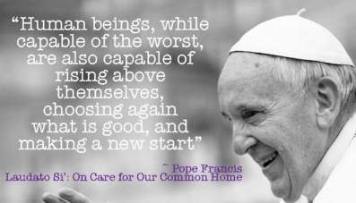  Laudato Si 71  “Through Noah, who remained innocent and just, God decided to open a path of salvation. In this way, he gave humanity the chance of a new beginning. All it takes is one good person to restore hope!”  People in the story of Noah turned away from God and chose to act badly;  this behaviour is called sin.  Psalm 139  An extract taken from Psalm 139 in praise of God’s Creation of each of us and his love for us.  You have searched me, Lord, and you know me. You know when I sit and when I rise; you perceive my thoughts from afar. You discern my going out and my lying down; you are familiar with all my ways. Before a word is on my tongue you, Lord, know it completely.  For you created my inmost being; you knit me together in my mother’s womb. I praise you because I am fearfully and wonderfully made; your works are wonderful, I know that full well.  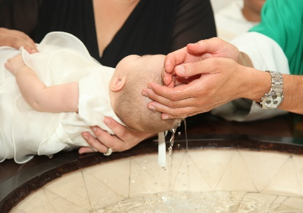  The Sacrament of Baptism is when a person becomes part of the Christian family and promises to love God.
  God | The Christian faith teaches that there is only one God, who is the creator and sustainer of the world. God is three persons – the Father, the Son and the Holy Spirit.
  Noah | God told the one good man, Noah to make a big boat called an ark because he was going to flood the world. (A Biblical character from Genesis).
  covenant | A formal agreement, a promise made between two people.
  sin | When we turn away from God’s way and choose to act badly.
  psalm | Psalms are songs and poems used to worship God.
  sacraments | An outward sign of an inward grace; Baptism, Reconciliation, Eucharist, Confirmation, Marriage, Anointing of the Sick, Holy Orders.
  baptism | The first sacrament which welcomes people into the Christian family.
  Bible | The holy book that Christians follow. It teaches Christians how they can show care like God. It is made up of 66 books (39 books in the Old Testament and 27 books in the New Testament).
  Old Testament | The first part of the Bible. The Old Testament talks about how the earth was created by God and was all written before Jesus arrived on Earth.
  New Testament | The second part of the Bible. Written after Jesus lived on Earth and introduces us to him, his birth, life and how he died to save humans on earth from their sins.
