Year 6 Transition Learning Projects
WC 15.06.2020: Your Network
This week’s learning project focuses on who your child can turn to and how to form friendships with other children.
It will give them the opportunity to create strategies to make friends, stay in touch with other children from primary school and the importance of staying safe online..
Transition Activities:
Monday- Your child might be attending a secondary school that none of their friends/peers are attending. Even if they are, they might not be in the same classes or on the same timetable as them. Therefore, they will need to make some new friends. Ask your child to make a top tips poster on the best way to make new friends. Get them to watch this short video to help them gather some ideas on the best way to make friends or speak to family members about how they made friends when they went to secondary school (this could be parents, older siblings, aunties/uncles etc).
Tuesday- In September, your child will be facing lots of changes and they will need to be reassured that they have people at home that are there to support them. Have a discussion about who they could turn to for help or advice in your household or family. Afterwards, ask them to create a diagram or pyramid of family and friends they would turn to. Get them to think about specific things they would go to particular people for.
Wednesday- At your child’s new secondary school, your child will have different members of staff for each lesson. It is important that your child begins to recognise these teachers as safe adults and considers who they will go to with problems and worries. Ask your child to research their new school website and find out which teachers are in different departments. Ask them to consider which teacher they may go to if they have forgotten homework, if they have concerns over a friendship group and if they are finding a piece of work difficult.
Thursday- Ask your child what online platforms they use; this could be games, social media or websites. Ask them how they know it’s safe and what they do online to keep themselves safe. Discuss how social media and technology will come into their lives more as they grow up and how it is really important to use them wisely and what impact this may have at school and in the future. Ask them to create a set of guidelines to make sure that they are safe online.
Friday- Your child may be leaving some of their friends from primary school and this may add to their worries about the transition. Have a conversation with your child about which of their friends are going to the same secondary school and which friends are going to different schools. Ask your child how they could keep in contact with them. For example: meeting outside of school in a safe place, using an online classroom that has been set up by your school or over the phone.

Staying Safe Online
In preparation for moving to secondary school, why not have a go at entering The Childnet Film Competition which invites young people aged 7-18 to create a 2 minute online safety film to inspire their peers to create a safe, supportive and fun online world around the theme ‘We want an internet where we’re free to…’. Within your video you could specifically aim the video at Y6 children who are making the step up to secondary school. You could do this by: highlighting the need to stay in touch with friends safely who move to other secondary schools and by Discussing how Y6 children could safely stay in contact with one other and offer support. The entries that make into the final shortlist will be judged by a prestigious panel made up of representatives from BAFTA, the BBC, the British Board of Film Classification, the BFI, Disney and the Motion Picture Association. The young people who create winning films and storyboards will receive great filmmaking and creative prizes for their school or youth group. Whether used at school or as a home learning project, the competition is a great way of exploring important internet safety messages with young people of all ages. Visit here for more information.
#TheLearningProjects

Year 6 Transition Learning Projects
WC 15.06.2020: Your Network - Example Work
Below are some examples of how your child could set out their work.
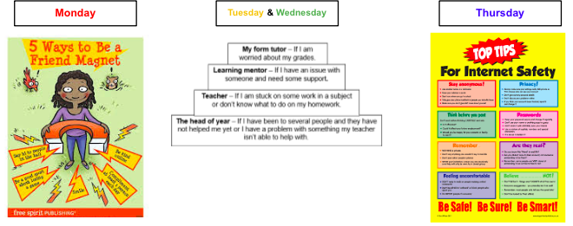

Additional Learning Resources Parents May Wish To Engage With:
- Here are more videos linked to making friends at secondary school that might be useful to your child - video 1 and video 2.
- Parent survival guide - this is a short video that discusses some of the concerns parents might have and tips on how to overcome them.
- This video has some tips for making friends at secondary school.
- This video offers advice on how to best prepare your child practically and emotionally for the start of secondary school.
- This website has some videos of worries your children may have and explains how other children have overcome them.
#TheLearningProjects

