Year 1 Home Learning
Week Beginning 29th June
Hello everyone, we hope you are all well. This week continues to include writing work from Oak Academy. You will need a pencil and paper for some of the activities. Please continue to choose a materials activity from the science curriculum homework. PhonicsPlay continues to be free, please have a go at some of the games. Thank you. We are missing you very much!
 | Monday | Tuesday | Wednesday | Thursday | Friday
Reading | Comprehension  Birthday Cake by Hannah Raven*  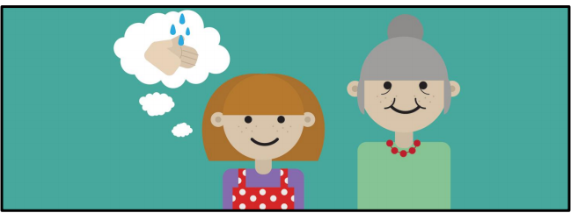  Read the text (preferably an adult read to the child). Highlight or record any unfamiliar words. | Comprehension  Birthday Cake by Hannah Raven*  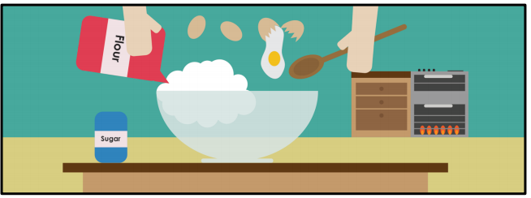  Child to re-read the text and answer question 1,2,3 and 4 | Comprehension  Birthday Cake by Hannah Raven*  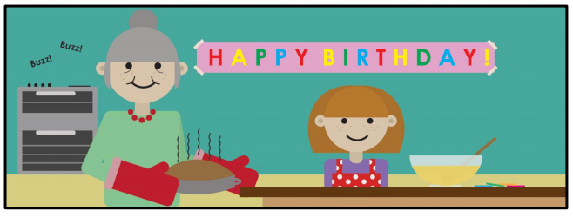  Re-read the text and continue to answer questions 5 and 6.  Now go through your answers with an adult. | Reading for Pleasure  Read E-book Incredible Animals  https://www.oxfordowl.co.uk/api/interactives/27301.html  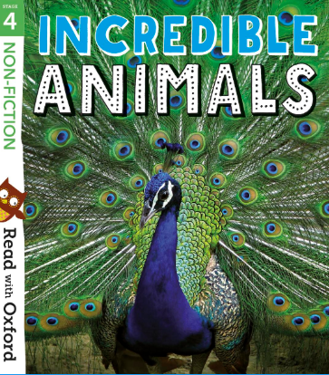 | Reading for Pleasure  Read E-book A vet’s week  https://www.oxfordowl.co.uk/api/interactives/29264.html  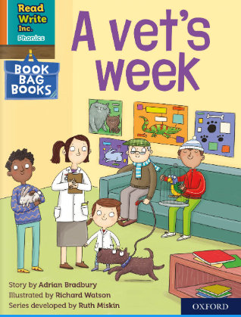
Writing+ Phonics | Fiction Writing  The tiger who came to tea  https://classroom.thenational.academy/lessons/the-tiger-who-came-to-tea | Fiction Writing  To commit a story to memory  https://classroom.thenational.academy/lessons/to-commit-a-story-to-memory-c1a5e7 | Fiction Writing  To understand how to identify and write questions  https://classroom.thenational.academy/lessons/to-understand-how-to-identify-and-write-questions | Fiction Writing  To begin to write our story  https://classroom.thenational.academy/lessons/to-start-to-write-our-story | Fiction Writing  To write the end of our story  https://classroom.thenational.academy/lessons/to-write-the-end-of-our-story

Maths  Whiterose | Lesson 1 – Counting in 2’s  Watch:  https://vimeo.com/425797171  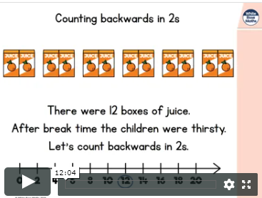  See additional sheet on counting in 2’s to complete* | Lesson 2 – Count in 5’s  Watch:  https://vimeo.com/425797292  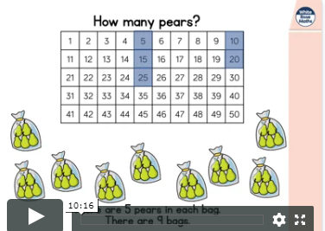  See additional sheet on counting in 5’s to complete* | Lesson 3 – Count in 10’s  Watch:  https://vimeo.com/425797444  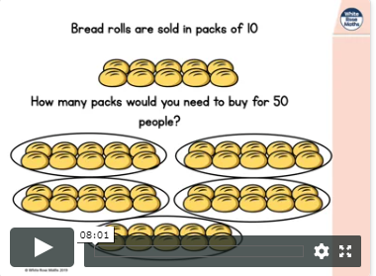  See additional sheet on counting in 10’s to complete* | Lesson 4 – Add equal groups  Watch:  https://vimeo.com/425797578  See additional sheet on adding equal groups to complete* | More or Less  His game help you to recognise number that are more or less than a given number.  https://www.topmarks.co.uk/learning-to-count/chopper-squad  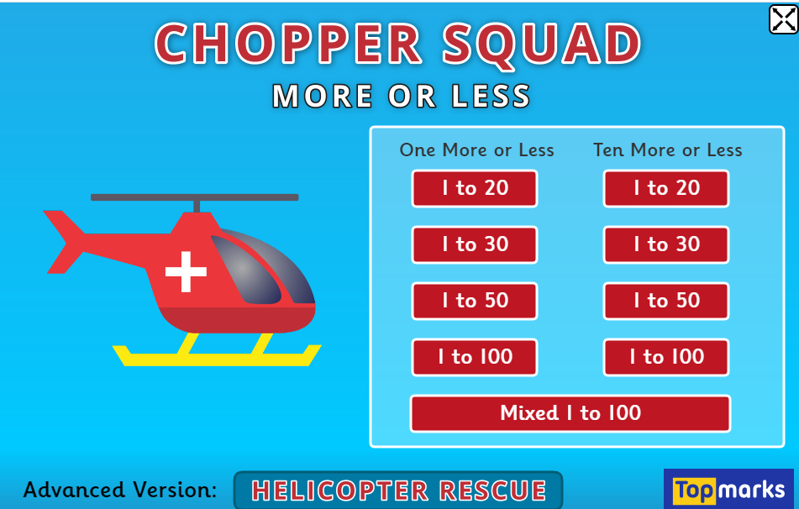
 | Please practise number bonds to 20. | Please practise writing your number names to thirty. | Please practise counting in 5’s up to 50. | Can you name some 3D shapes around your house? | Please practise counting in 10’s up to 100.
Come and See  Universal Church - Neighbours | Explore: Neighbours all around  What do you think a neighbour is?  Talk about your friends in school and the people who live in your neighbourhood. Talk about the differences and similarities.  Everyone who lives in God’s wonderful world is your neighbour. CAFOD is an international organization that helps to make life easier for our global neighbours who are not as well off as we are. They try to make the world a fairer, more just place.  Read Marie-Dorianne’s story*  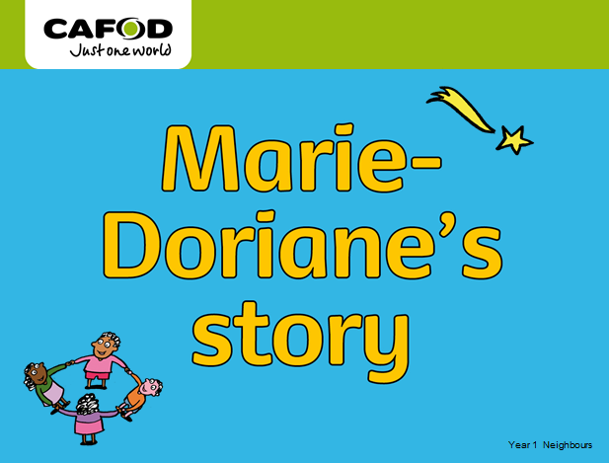 | Explore: Neighbours all around  Recap the PowerPoint from the previous day about Mari-Doriane’s Story*  Answer key questions:  Q Where does Marie-Dorianne live?  Q How old is she?  Q How is Marie-Dorianne like you?  Q Marie-Dorianne is not your next-door neighbour; she isn’t a neighbour in your class; she isn’t a neighbour in your school. Why do you think Marie-Dorianne is your neighbour?  Q CAFOD helps our neighbours around the world, particularly those who are poor.  Q How has CAFOD helped Marie-Dorianne’s family? | Explore: Neighbours all around  Activity  Talk about Marie-Doriane’s life and the similarities between the life we here. Think about how and why Marie-Doriane is our neighbour. Complete the worksheet below. There are 3 levels of difficulty, choose an appropriate one.  (Hello Neighbour*)  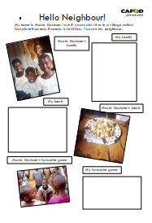 | Explore: Neighbours all around  Activity  Write/copy the name of someone you call your neighbour on a template of a person. Draw the person and say why you call that person your neighbour.  Use the person template*  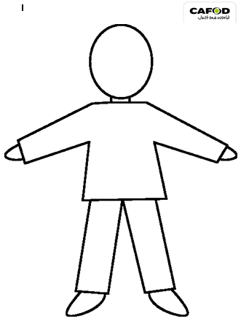  Please send photos/pictures of any Come and See work about Neighbours, by tweeting pictures on the school Twitter with #CAFOD Thank you | Explore: Neighbours all around  REFLECTION: Neighbours around the world  Reflect using the Neighbours Around Our World PowerPoint*  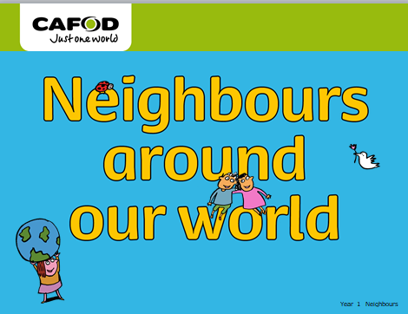  Think about neighbours at home… in school… around the world…
Also refer to the additional activities that we have provided on the school website to complete as you choose. * = see attached files

Learning from home Extra Ideas (Animal and Zoo based)
Use the ideas below:

Create a poster to advertise Chester Zoo or another zoo that you know. Include a title, catchy slogan, short, snappy sentences, persuasive and emotive language, an offer e.g. free child entry for every three adult tickets purchased, pictures/photographs, information e.g. price, opening times. Perhaps you could send your poster to your chosen zoo? You never know, they might use it!

Animals are divided into two main groups: vertebrates (have a backbone), invertebrates (do not have a backbone). Vertebrate are divided into fish, mammals, birds, reptiles and amphibians. Can you find examples of animals that would fit these 5 categories?

A silhouette is an image of something that is represented as a solid shape or single colour so that we only see the outline. Create some wild animal silhouettes! Use your silhouettes to make a picture or a shadow show, using a torch and a dark room.

Think about a wild animal that you might find in a zoo or your favourite wild animal. Can you find out some more information about it? Where does it live? What does it eat? What does it look like? What size is it? Are there any other interesting facts about your wild animal? Use the information to create a fact file of your wild animal. Don’t forget to include a picture!

Look at a world map. Can you name each continent? Can you find a wild animal that lives on each continent?

Imagine you have your own zoo. Design a map of your zoo. What animals do you have? How much space will they have? Are they inside or outside? Is there anywhere for visitors to get food and drink?

