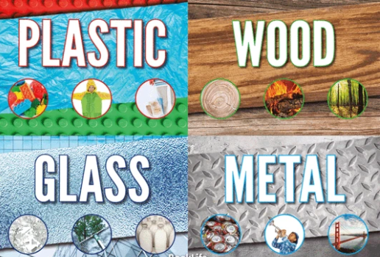

Theme: Materials and their uses
You can complete as many of the tasks as you choose in the time given, but you must make sure that it is well presented work to share or display and show off your skills!

Thinking Skill | Activities
Knowledge  (Remember) | - Make a list of the materials in different rooms in your house. Eg. In the living room, the table is made from plastic. In the bathroom the tap is made from metal.
Comprehension  (Understand) | - Explain and distinguish between an object and the material from which it is made by looking and touching different materials. Use a feely bag and put some materials inside Eg, rock, metal, wood and plastic. Can you name the materials just by feeling them?  - Become familiar with the names of materials and properties such as: hard/soft; stretchy/stiff; shiny/dull; rough/smooth; bendy/not bendy; waterproof/not waterproof; absorbent/not absorbent; opaque/transparent.
Application  (Apply) | - Make a fact book about materials and what their uses are. Can you write it using the following titles for each page? Metal, Plastic, Wool, Fabric, Glass
Analysis  (Analyse) | - Compare the uses of the different materials. What would you use paper for? Is it the best material to write on?  - Singing about materials and their properties will help reinforce the fact that it is not only fabrics that are materials but other substances such as clay, metal, water and glass. You could share it with your class.  - Performing simple tests to explore questions, for example: ‘What is the best material for an umbrella? … for lining a dog basket? … for curtains? … for a bookshelf? … for a gymnast’s leotard?
Synthesis  (Create) | - Make a model from recycling materials. Discuss what materials you have use and why?  - Make a picture uses different types of materials. Add paint to make it colourful and bright.  - Keep a ‘busy box’ with things like string, wrapping paper scraps, patty pans, paddle pop sticks, stickers and straws you can use to make whatever you wants.
Evaluation  (Evaluate) | - Write a short story based on a famous materials story such as – The Three Little Pigs, Goldilocks,

Please bring into school during the week of:

