Come And See  Universal Church – God’s People | Explore: Ordinary people who do extraordinary things  Look at a photograph, picture or magazine-cutting of someone you look up to or admire (e.g. celebrities, sports professionals, family members, and teachers). Share your pictures with an adult at home and state why this person is your role model.  Answer key questions:  Q What are the qualities you like in this person?  Q Is it something they were born with, something they developed, or both?  Key words: ordinary, extraordinary, admire, saint, martyr  Communion of Saints, peace, justice | Explore: Ordinary people who do extraordinary things  Read Eric’s Story* (powerpoint)  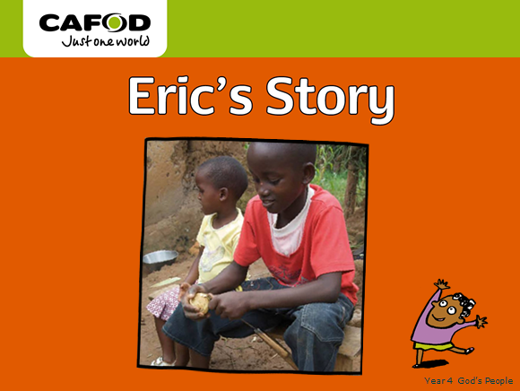  Thanks to our help, CAFOD can continue to help families like Eric’s by helping them find ways to help themselves through work, such as growing and selling  vegetables.  Answer key questions:  Q How is Eric similar to you?  Q How is Eric different from you?  Q Is Eric extraordinary in any way?  Q What do you feel about Eric?  Q How do you think Eric feels about himself?  Q Why do you think Eric helps his family?  Q What do you think makes someone extraordinary? | Explore: Ordinary people who do extraordinary things  Activity  Complete the worksheet about Eric’s story, My story.*  Use the photos (from the Previous day Eric’s Story Powerpoint) to help you to retell Eric’s Story and then tell your own story focusing on the similarities in your lives.  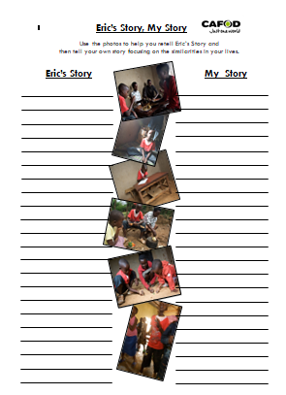 | Explore: Ordinary people who do extraordinary things  Activities (choose 1 from the following activities)  1. Using the pictures of your role models, write about them. Who is your person? What do they do? What are the qualities you like? Which of these qualities do you have?  2. Design and make your own Book of Qualities. In this book, you will begin to record qualities that you admire in other people. You could continue to add to these throughout the topic.  Please send photos/pictures of any Come and See work about God’s People, by tweeting pictures on the school Twitter with #CAFOD Thank you. | Explore: Ordinary people who do extraordinary things  RESPECT  Play some quiet music.  Have a selection of images on view of the person/people you have said you admire. On a star template*, you can write down one word to describe a quality you admire in someone else.
* = see attached file

