Learning Project WEEK 3 - Viewpoints
Age Range: Y3/4
Maths Tasks | Reading Tasks
- Play on Hit the Button - focus on number bonds, halves, doubles and times tables.  - Practise telling the time. This could be done through this game (scroll down to access the game). Read to the quarter hour and the nearest 5 minutes.  - Get a piece of paper and ask your child to show everything they know about Multiplication. This could be pictures, diagrams, explanations, methods etc. They can be as creative as they want to be.  - Practise counting forwards and backwards from any given numbers in 100s. | - You could share a story together. This could be a chapter book where you read and discuss a chapter a day.  - Listen to your child read and let them discuss what they have read. Encourage them to read with expression and intonation.  - Watch Newsround and discuss what is happening in the wider world.  - Get your child to read a book on Oxford Owl, discuss what your child enjoyed about the book.  - Get your child to read a book on Active learn and complete the activities. These focus on comprehension skills.  - Explore new vocabulary you find when reading. What are the origins of this word? Can it be modified? Can you find any synonyms or antonyms for your new word?  - With your child, look in magazines, newspapers and books for new vocabulary they are unfamiliar with.They could use a highlighter to highlight in magazines and newspapers.
Spelling Tasks | Writing Tasks
- Practise the Year 3/4 for Common Exception words.  - Practise your spelling on Spelling Frame  - Choose 5 Common Exception words. Write a synonym, antonyms, the meaning and an example of how to use the word in a sentence. Can the word be modified?  - Choose 5 Common Exception words and practise spelling them using pyramid words. Write the word in a pyramid, e.g.  s  sp  spe  spel  spell  spelli  spellin  spelling | - Write a letter to a family member telling them all about how their day has been.  - Write a list poem about all the things they like. Which adjectives and adverbs could they include too?  E.g I like eating juicy, sweet strawberries.  - If they were to become a superhero what would their superpower be? Write a character description of them as a superhero. Explain how they save the day.  - Retell a traditional tale from another character’s point of view. E.g Tell the three little pigs from the wolf’s perspective.  - Design an information leaflet that highlights how children can keep safe.  - Take part in a writing master class.
Learning Project
The project this week aims to provide opportunities for your child to learn more about different viewpoints. Learning may focus on physical viewpoints in terms of what you can see outside of the window at home, what others can see looking into your home and then progress onto personal viewpoints and of others.

- Let’s Wonder:

Draw a picture of themself and label their drawing with the qualities they have.
How do others see them differently? Ask people at home to add to their qualities.
How are they different to other children in different parts of the world? What makes them
similar to other children around the world?

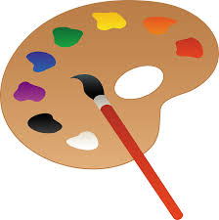
- Let’s Create:

Complete an observational drawing of what they see outside a window in their house. Then get out into the garden and find natural forms such as stones, leaves, flowers and animals. Complete sketches, showing an awareness of different viewpoints of the same object. Remember to concentrate on tone and shading.

- Be Active:

Move around their home and garden taking photographs from different viewpoints. Which photos do they like? Do the people they live with like the same photos as them? Why? Why not?
Recommendation at least 2 hours of exercise a week.

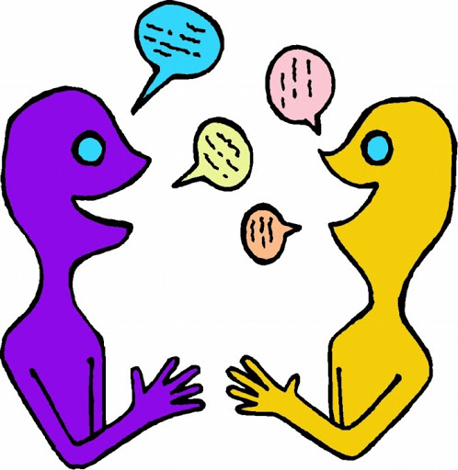
- Time to Talk:

Talk about keeping safe, discuss different ways to keep safe. Basic hygiene rules, road safety, internet safety, water safety, being safe around the home, stranger danger. How do different people view this?

- Understanding Others and Appreciating Differences:

Listen to different pieces of music from around the world, which styles of music do they prefer and why? Music Maybe they could learn a song by heart and perform it.

- Reflect:

Design their own ideal world. Would their world contain the same things as other people? Which things are most important to them? What are they going to include?

