The story of Martin Luther King.

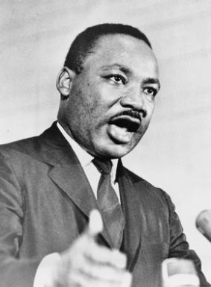
Many years ago, white men went to Africa and captured black people to use as slaves. These African women, men and children were crowded together on slave ships and transported to the West Indies and the south of the United States of America, where they were sold to work on the sugar and cotton plantations. Slavery was banned in 1808 but it still continued until 1860. The African slaves were eventually freed, but they could only get poorly paid jobs and were treated badly by some white people.

Martin was born in Atlanta, Georgia, one of the southern states of America in 1929. He was the eldest son of a Baptist minister. Martin was a descendent of African slaves. He was brought up to know and love Jesus. He knew that God, our creator, had made all human beings in love and had given them dignity and honour no matter what colour they were or family group that they belonged to. Martin was a gifted student. He worked hard at his studies and became a Baptist minister like his father and grandfather. During his studies at Boston University, he read about an Indian man named Mahatma Gandhi. Gandhi believed in equality and love for all people and that injustice and wrong could be changed by non-violent methods.

Martin married and became a minister of a Baptist church in Montgomery, Alabama. In this part of America, some people still treated black people badly. They wanted to have schools for white people only and special ‘whites only’ seats on buses. One day, a black lady called Rosa Parks got onto a bus and sat in a whites-only seat. She refused to give up her seat to a white person who was standing. Rosa was arrested. Her friends went immediately to Martin to tell him what had happened. He was very sad about it and organised a boycott of the buses to protest against the segregation and treatment of black people. Many people, black and white, joined him. The protest lasted for 381 days. During that time Martin and his family had a very difficult time. His life was threatened, his home bombed and he was arrested. Martin never returned violence with violence: all his protests were peaceful and respectful of others. He remembered that Jesus’ friends continue to love others whatever happens. Eventually the peaceful actions won. It became illegal to have whites-only seats on buses. Everyone was entitled to sit where they liked.

Martin’s work was very successful because it was based on how the friends of Jesus would act. Like Jesus, he told people to love their enemies. Martin’s message to those who hated him and made him suffer was that no matter what they did to him he would continue to love them.

Martin became the leader of Christians who were working for the rights of all people. This was called the Civil Rights movement. In 1963 he led a big campaign in Alabama for black voting rights, for better housing and education for black people and to get rid of any segregation of black and white people. It was not easy as the attitude of some white people in that part of America made them treat black people as lesser than white people. He made a speech in Washington which became very well known, he began by saying:

‘I have a dream that my four children will one day live in a nation where they will not be judged by the colour of their skin but by the content of their character. I have a dream today.’

In 1964 he won the Nobel Peace Prize for all he had done to help others.

Martin’s life had often been threatened and he had a feeling that his death was going to be quite soon. On 3rd April 1968 he said to his friends that he felt he had been to the top of the mountain and had seen the Promised Land. He meant that he knew heaven was near. The very next day he was shot dead. Thousands of people went to his funeral and remembered how Martin showed the power of Jesus’ love in his life and actions.
(taken from Recent Friends of Jesus: Victoria Hummell)

