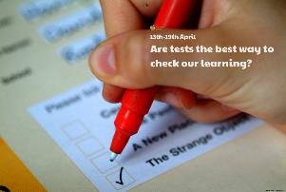

Choose a mental maths challenge for yourself e.g. practise 8 times tables, number bonds to 100. Create your very own speed test for it! Complete the challenge and either record your score or how long it takes you to complete the test. You can then practise and complete the test again, trying to beat your score or time.

Play a game of ‘Simon Says’ to test your listening skills and your reactions. Who is best at it in your home? Can you think of any other games to test your reactions e.g. musical bumps or statues?

Describe a test you have done before. Think about how you felt before, during and after it. Record your vocabulary or show your emotions through art.

Create a leaflet with advice and tips for preparing for a test. Include a title, headings and sub-headings, different fonts, an attractive and eye-catching design, pictures or drawings.

Create a fun and imaginary test for someone in your home to take e.g. a test to become a unicorn, a pirate or a stealth ninja! Make a certificate for them if they pass.

Can you find out what your heart rate is by finding your pulse? Have you ever noticed when you feel nervous or excited (like you might feel before a test), your heart rate increases? Find out why this is.

Find out what exams or tests other members in your family did when they were at school. You could even phone grandparents or other family friends. Did they do spelling tests? Are the exams and tests different or the same? How?

**Learning from Home**

Use the ideas below, alongside this week’s resource, to support your home learning.