Learning Project WEEK 1 - My Family
Age Range: Y3/4
Maths Tasks | Reading Tasks
- Play on Hit the Button - focus on number bonds, halves, doubles and times tables.  - Practise telling the time. This could be done through this game (scroll down to access the game). Read to the quarter hour and the nearest 5 minutes.  - Get a piece of paper and ask your child to show everything they know about Addition. This could be pictures, diagrams, explanations, methods etc. They can be as creative as they want to be.  - Practise counting forwards and backwards from any given number in 1s. | - You could share a story together. This could be a chapter book where you read and discuss a chapter a day.  - Listen to your child read and let them discuss what they have read. Encourage them to read with expression and intonation.  - Watch Newsround and discuss what is happening in the wider world.  - Get your child to read a book on Oxford Owl, discuss what your child enjoyed about the book.  - Explore new vocabulary you find when reading. What are the origins of this word? Can it be modified? Can you find any synonyms or antonyms for your new word?  - With your child, look in magazines, newspapers and books for new vocabulary they are unfamiliar with.They could use a highlighter to highlight in magazines and newspapers.
Spelling Tasks | Writing Tasks
- Practise the Year 3/4 for Common Exception words.  - Practise your spelling on Spelling Frame  - Choose 5 Common Exception words. Write synonyms, antonyms, the meaning and an example of how to use the word in a sentence. Can the word be modified?  - Choose 5 Common Exception words and practise spelling them using forwards backwards. Write the word forwards then write the words backwards, e.g. forwards sdrawrof | - Write a recount of your day. This could be used in history one day to show what happened during this period.  - Write a character description of a member of their family. What do they look like? How do they behave? etc...  - Write a story involving members of their family. Do they have to defeat a monster? or find something they have lost?  - Write a set of family rules, could they begin with ‘We always…..’ rather than ‘We do not ………’  - Write a letter/email/ text message to a member of their family that they have not seen this week.  - Take part in a writing master class.
Learning Project
The project this week aims to provide opportunities for your child to gain a better understanding of their own family. Learning may focus on what different makeup of families, what traditions your family has, stories linked to your family etc.

- Let’s Wonder:

Who is in your child’s immediate family? What other relatives do they have? How does their family link together? How many people do they have in their family? Why not spend time looking through old photos and talking about the people in their families. What family stories can they tell? How is life different to their parents? grandparents?
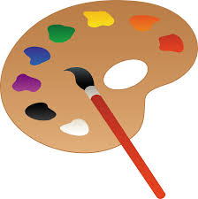
- Let’s Create:

Create a piece of artwork entitled ‘Family’. This could be a drawing, a self portrait, a sculpture or collage. Could they copy another artist's style? Which materials have they chosen to use and why? How do they feel about their piece of artwork? What would they change or not? Family portraits.

- Be Active:

Go Noodle with the family or have a family workout. Fancy a dance? There are lots of dance videos they could try. Dance. Maybe try some Yoga.
Recommendation at least 2 hours of exercise a week.

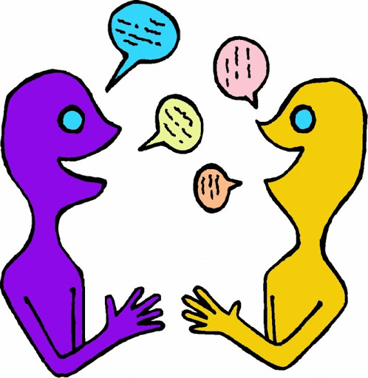
- Time to Talk:

Perhaps they could play a board game, facetime a member of their family they have not seen this week, enjoy a family indoor picnic or have a family dinner.

- Understanding Others and Appreciating Differences:

Discuss how their family is different to other people’s families. Discuss whether all families are the same? Does it matter? Do all families have the same faith? Do all families worship in the same way?

- Reflect:
Find out what music their family members enjoy. Do they like the same music? What is their favourite song? They could listen to different pieces of music together with their family. Do they like/dislike any particular types of music and why? Can they Identify the instruments they can hear and describe how the music makes them feel? Why not get them to listen to some of the classics?

