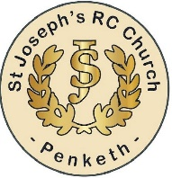

**NEWS FROM ST JOSEPH’S RC CHURCH PENKETH**

Mary’s Meals

This is a great charity to help children around the world, this month appeal is for South Sudan, whose people are living on a knife’s edge with violence, poverty, and hunger. Some 2.2 million children around the world are not receiving education. The UN estimates that 55% have insufficient food intake and 31% of under 5s are suffering from malnutrition. So please support www.mary’smeals.org.uk/