Year 1 Home Learning
Week Beginning 6th July
Hello everyone, we hope you are all well. This week continues to include writing work from Oak Academy. You will need a pencil and paper for some of the activities. Please continue to choose a materials activity from the science curriculum homework. PhonicsPlay continues to be free, please have a go at some of the games. Please continue to go onto the Oxford Owl website and read the free e-books. Don’t’ forget to put you come and See work on the School Twitter with #CAFOD. We are missing you very much! Thank you for working so hard.
 | Monday | Tuesday | Wednesday | Thursday | Friday
Reading | Comprehension  Amazing Animals by Hannah Raven*  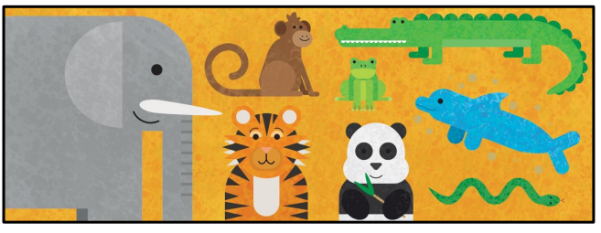  Read the text (preferably an adult read to the child). Highlight or record any unfamiliar words. | Comprehension  Amazing Animals by Hannah Raven*  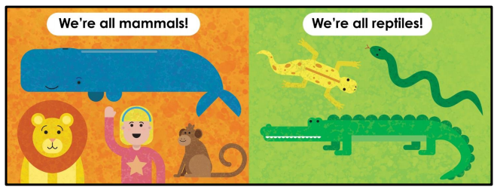  Child to re-read the text and answer question 1,2,3 and 4 | Comprehension  Amazing Animals by Hannah Raven*  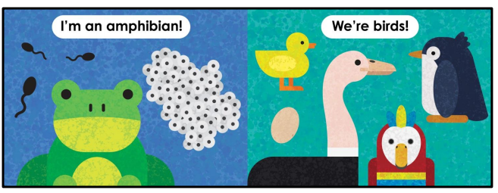  Re-read the text and continue to answer questions 5 and 6.  Now go through your answers with an adult. | Reading for Pleasure  Read E-book  Minibeast Poems  https://www.oxfordowl.co.uk/api/digital_books/1329.html  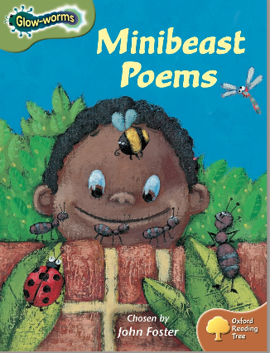 | Reading for Pleasure  Read E-book  Rumpelstiltskin  https://www.oxfordowl.co.uk/api/digital_books/1491.html  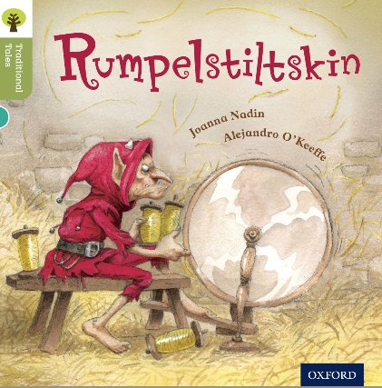
Writing+ Phonics | Information Text  Terrifying T- Rex  https://classroom.thenational.academy/subjects-by-year/year-1/subjects/english | Information Text  To commit an information text to memory  https://classroom.thenational.academy/lessons/to-commit-an-information-text-to-memory | Information Text  To understand how to use the past tense  https://classroom.thenational.academy/lessons/to-understand-how-to-use-the-past-tense | Information Text  To start to write our information text  https://classroom.thenational.academy/lessons/to-start-to-write-our-information-text | Information Text  To continue to write out information text  https://classroom.thenational.academy/lessons/to-continue-to-write-out-information-text

Maths  Whiterose | Lesson 1 – Make Arrays  Watch:  https://vimeo.com/428004469  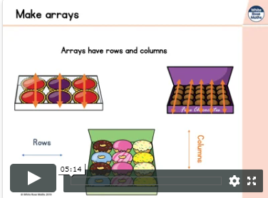  See additional sheet on make arrays to complete* | Lesson 2 – Make Doubles  Watch:  https://vimeo.com/428004541  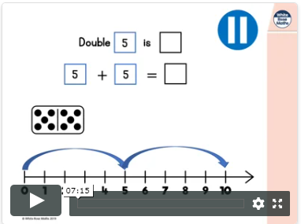  See additional sheet on make  doubles to complete* | Lesson 3 – Make equal groups  Watch:  https://vimeo.com/428004616  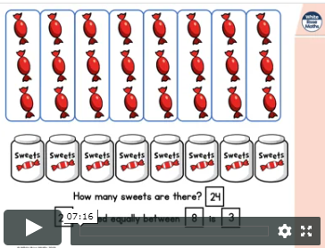  See additional sheet on make equal groups(sharing) to complete* | Lesson 4 – Make equal groups  Watch:  https://vimeo.com/428004753  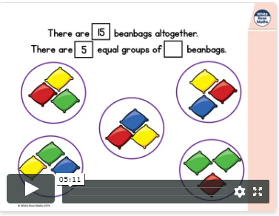  See additional sheet on make equal groups(grouping0 to complete* | Number Bonds  Try the addition to 20 and suntraction within 20.  https://www.topmarks.co.uk/maths-games/hit-the-button  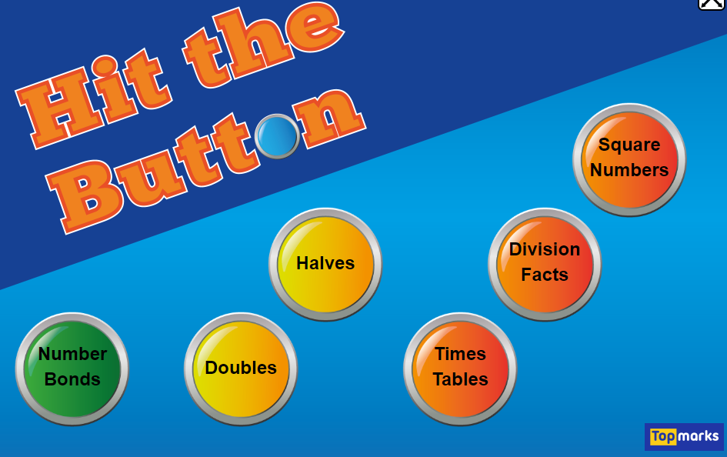
 | Please count 10 pence’s up to £1.How many are there? | Please practise writing your number names to fifty. | Please practise counting in 2’s up to 50. | Can you name some 2D shapes around your house? | Please practise counting in 5’s up to 100.
Come and See  Universal Church - Neighbours | Give thanks to God for neighbours everywhere.  Go outside and  stand in a space. Close your eyes. Think about yourself in your space. What can you hear? Now open your eyes and look around you. What do you see? What do you see above you? If you were here tonight, what would you see above you? What are you standing on?  Look around you.  Look at the people/family who share this space with you. You are a neighbour to each one.  There is only one sun, one sky, one world. We share all these with one another.  Please send photos/pictures of any Come and See work about Neighbours, by tweeting pictures on the school Twitter with #CAFOD Thank you | Give thanks to God for neighbours everywhere.  Read the Powerpoint Psalm 18*  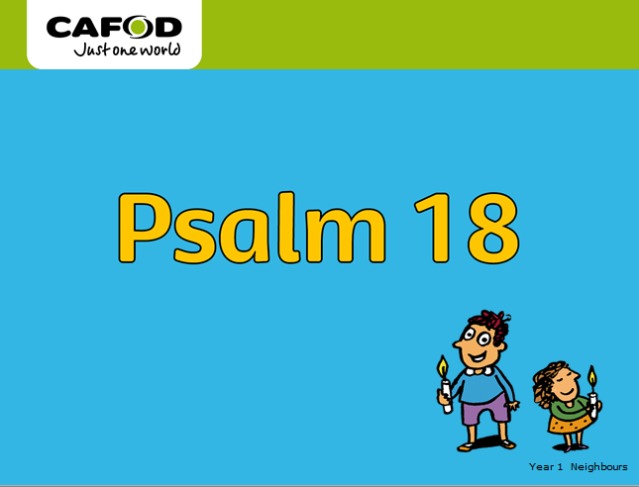  Answer key questions:  Q How does the sky tell us how wonderful God is?  Q Why does looking at the sky help us to think about neighbours everywhere?  Q We have friends and neighbours throughout the world. They are called our global neighbours/  friends. Why do you think people in our own and other countries all our neighbours?  Q How do we show God’s love to our neighbours?  Key Words: neighbour, love, world, Fairtrade, global, family, psalm, share | Give thanks to God for neighbours everywhere.  Activity  Produce a sky at night collage on black paper using silver and gold squares of paper for the stars and moon OR produce a sky during the day collage on blue paper using gold/yellow squares of paper for the sun and white/grey for the clouds. Choose the appropriate line from psalm 18 to stick next to the collage. Add photographs of global neighbours* to show that we all share the same sky, the same world  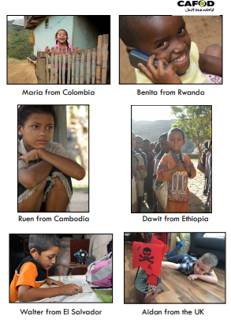 | Everyone is our neighbour.  Read the story of the Good Samaritan.*  Samaritans lived in Samaria and that Jews and Samaritans would have nothing to do with one another. They could not get on because they could not agree about what they believed, so they became enemies.  Answer key questions:  Q Can you answer Jesus’ question – “Which of the three was a neighbour to the man?”  Q How do you think the injured man felt when the first two men walked away?  Q What did the injured man need?  Q Why was it strange that a Samaritan helped?  Q Think of a time when you have helped someone. | Everyone is our neighbour.  Read Powerpoint “Helping Our Neighbours”* to show how CAFOD helps our neighbours.  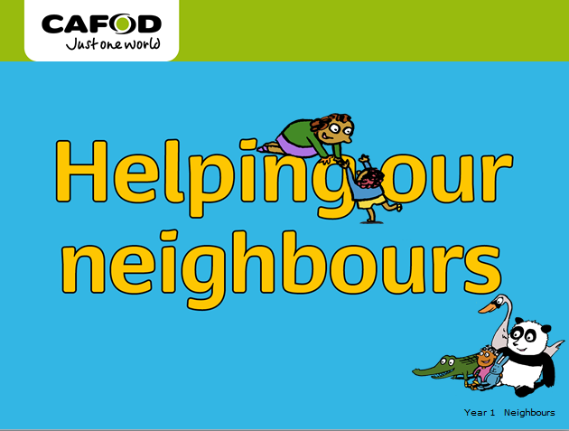  Activity  Look a set of pictures of needs and wants* Talk about the differences between needs and wants, we know that many of our global neighbours do not have what they need.  Can you sort out the pictures into two groups: wants and needs.  How do you think CAFOD works hard to change this?
Also refer to the additional activities that we have provided on the school website to complete as you choose. * = see attached files

