Come And See  Universal Church – God’s People | Christians are invited to be saints.  Read the PowerPoint presentation of Pope Benedict XVI’s Big Assembly.*  Discuss about what the Pope said.  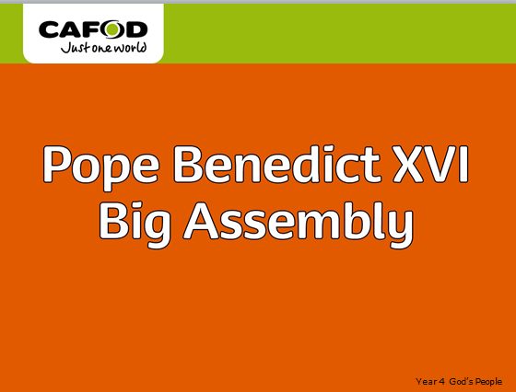  Answer Key Questions:  Q What are the qualities you see in others that you would most like to have yourself?  Q What kind of person would you really like to be?  Q How did Sorcha use money for a good purpose?  Q How can you become holy, as the Pope suggests you can?  Q Why does Pope Benedict say that some people do not find true happiness? Compare thoughts and ideas. | Christians are invited to be saints.  Activities(choose one of the following)  1. Start to create a collage display, which can be added to as the topic progresses – “Living a saintly life” – include pictures, drawings, poems, prayers, recent events etc.  2. Can you produce a mind map on paper or using mind mapping software – “What kind of person would I really like to be?”  Please send photos/pictures of any Come and See work about God’s People, by tweeting pictures on the school Twitter with #CAFOD Thank you.  Key words: ordinary, extraordinary, admire, saint, martyr, Communion of Saints, peace, justice | Oscar Romero –  A recent martyr showing us what God is like.  Read the PowerPoint presentation about Oscar Romero. (El Salvador is in South America: See if you can find it on a map)  A martyr is someone who dies for what they believe.  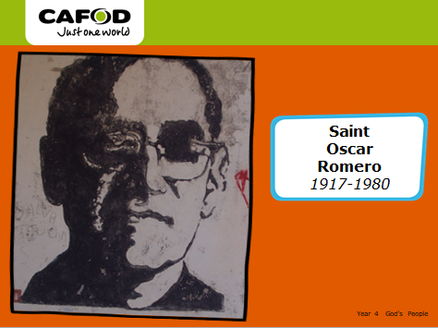  Answer Key Questions:  Q What made Oscar Romero extraordinary?  Q Why do we call Oscar Romero a martyr?  Q Why does CAFOD look to Oscar Romero as an example?  Q How does Romero’s story help to show us what God is like? | Oscar Romero –  A recent martyr showing us what God is like.  Activities(choose one of the following)  1. Read and recap information about Oscar Romero. (from previous day)How and why is Oscar Romero remembered, include a brief description of his life and work, giving reasons for his words and actions? Make a poster about Oscar Romero stating these information.  2. Read Romero Cross activity* and design your own Romero cross.  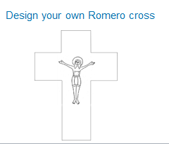 | Oscar Romero –  A recent martyr showing us what God is like.  RESPECT  Play some quiet music.  Think about the work and actions of Oscar Romero.  Look at the quote below, think quietly about Oscar Remero’s life.  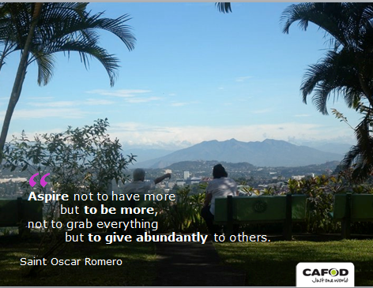
* = see attached file

