Learning Project WEEK 7 - Celebrations
Age Range: Y3/4
Maths Tasks | Reading Tasks
- Play on Hit the Button - focus on number bonds, halves, doubles and times tables.  - Practise telling the time. This could be done through this game (scroll down to access the game). Read to the quarter hour and the nearest 5 minutes.  - Get a piece of paper and ask your child to show everything they know about Money. This could be pictures, diagrams, explanations, methods etc. They can be as creative as they want to be.  - Practise counting forwards and backwards from any given number in 4s. | - You could share a story together. This could be a chapter book where you read and discuss a chapter a day.  - Listen to your child read and let them discuss what they have read. Encourage them to read with expression and intonation.  - Watch Newsround and discuss what is happening in the wider world.  - Get your child to read a book on Oxford Owl, discuss what your child enjoyed about the book.  - Explore new vocabulary you find when reading. What are the origins of this word? Can it be modified? Can you find any synonyms or antonyms for your new word?  - With your child, look in magazines, newspapers and books for new vocabulary they are unfamiliar with.They could use a highlighter to highlight in magazines and newspapers
Spelling Tasks | Writing Tasks
- Practise the Year 3/4 for Common Exception words.  - Practise your spelling on Spelling Frame  - Choose 5 Common Exception words. Write a synonym, antonyms, the meaning and an example of how to use the word in a sentence. Can the word be modified?  - Choose 5 Common Exception words and practise spelling them using words within words. Write the word and find smaller words within them, e.g. spelling = line, gel, in, etc…. | - Write a postcard to a family member recounting a celebration that has just taken place.  - Write a set of instructions for ‘How to play the new game?’ Remember to include a list of things they will need. Also not forgetting to include headings and subheadings. Then write their set of instructions, remembering to include imperative verbs. (Verbs that command you to do something). Think about the key rules!  - Write a non-chronological report about a particular religious festival they have found out about.  - Write a scary story that would be great to read aloud on Halloween. Use the images on Spooky to give them some inspiration.  - Design a card celebrating a religious celebration, remember to include a poem/verse for inside. You could make either an Eid, Easter, Diwali card etc….  - Take part in a writing master class.
Learning Project
This project this week aims to provide opportunities for your child to learn more about celebrations. Learning may focus and different types of celebrations that take place and who may celebrate them. It could look at how people celebrate different events differently in other parts of the world.

- Let’s Wonder:

How are birthdays celebrated around the world? India China America Africa etc.. maybe there's a particular country they would like to find out about. Create fact files to show the similarities and differences between them.
- Let’s Create:

Create a board game that focuses on celebrations. Think about what they can learn from it? Think about how to play the game. Is it going to be a game like Monopoly or Snakes and ladders? Are they going to need a dice? Cards? Characters? etc….

- Be Active:

Why not play a game of hopscotch? Can’t find any chalk? Use a stone from the garden. Raining? Build an indoor den and have an imaginary celebration with their toys.
Recommendation at least 2 hours of exercise a week.

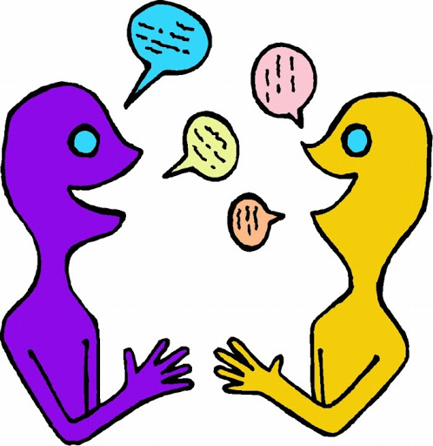
- Time to Talk:

Look through old photos of previous celebrations them and their family have taken part in. What can they remember happened? Why do they and their families celebrate the way they do?

- Understanding Others and Appreciating differences:

How many different types of celebrations are there? Who celebrates Christmas? St Patricks? St George? St David? Easter? Eid? Diwali? Chinese new year? And how? Which celebrations have they taken part in? What usually happens?

