Year 6 Easter Activity
During the Easter holidays, we would like you to create a piece of artwork related to the events of Holy Week. This could be about Palm Sunday, The Last Supper, Good Friday or Easter Sunday when we celebrate the resurrection of Jesus. Remind yourself of the story first before you create it.

Below are a few examples to inspire you.

You don’t have to use just paint or colour. You can create a piece of art using things you can find in your gardens – leaves, sticks, wood, flowers etc.

When you have completed your artwork, take a picture of it and send it to @stvincentsrcp in a tweet to us so we can see all of your wonderful creations!
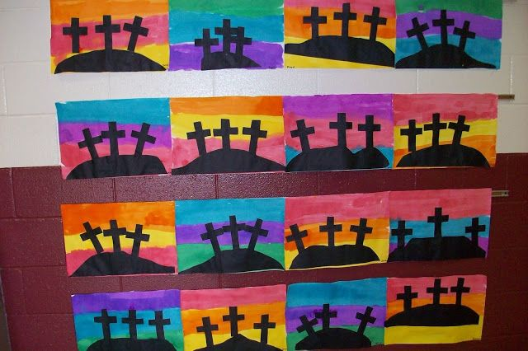
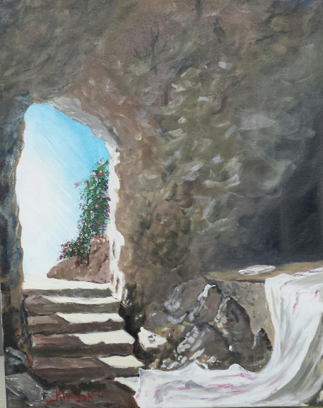
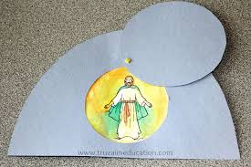
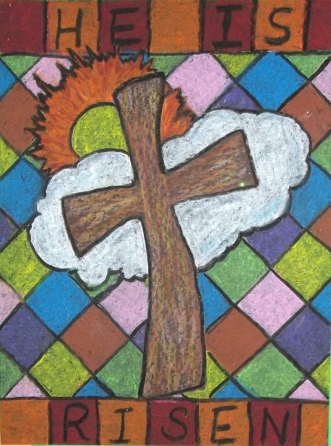
Enjoy!

