Chloe and Phoebe were sisters, Chloe was seven and Phoebe was three. Usually they were great friends, but one day Chloe was in a bad temper because mum had told her off for not letting Phoebe play with her toys.

‘Right’ thought Chloe, I’ll get my own back.’ so she got a felt tip and she wrote Phoebe’s name on the back door. ‘Aha,’ she thought, ‘now Phoebe will get into trouble’.
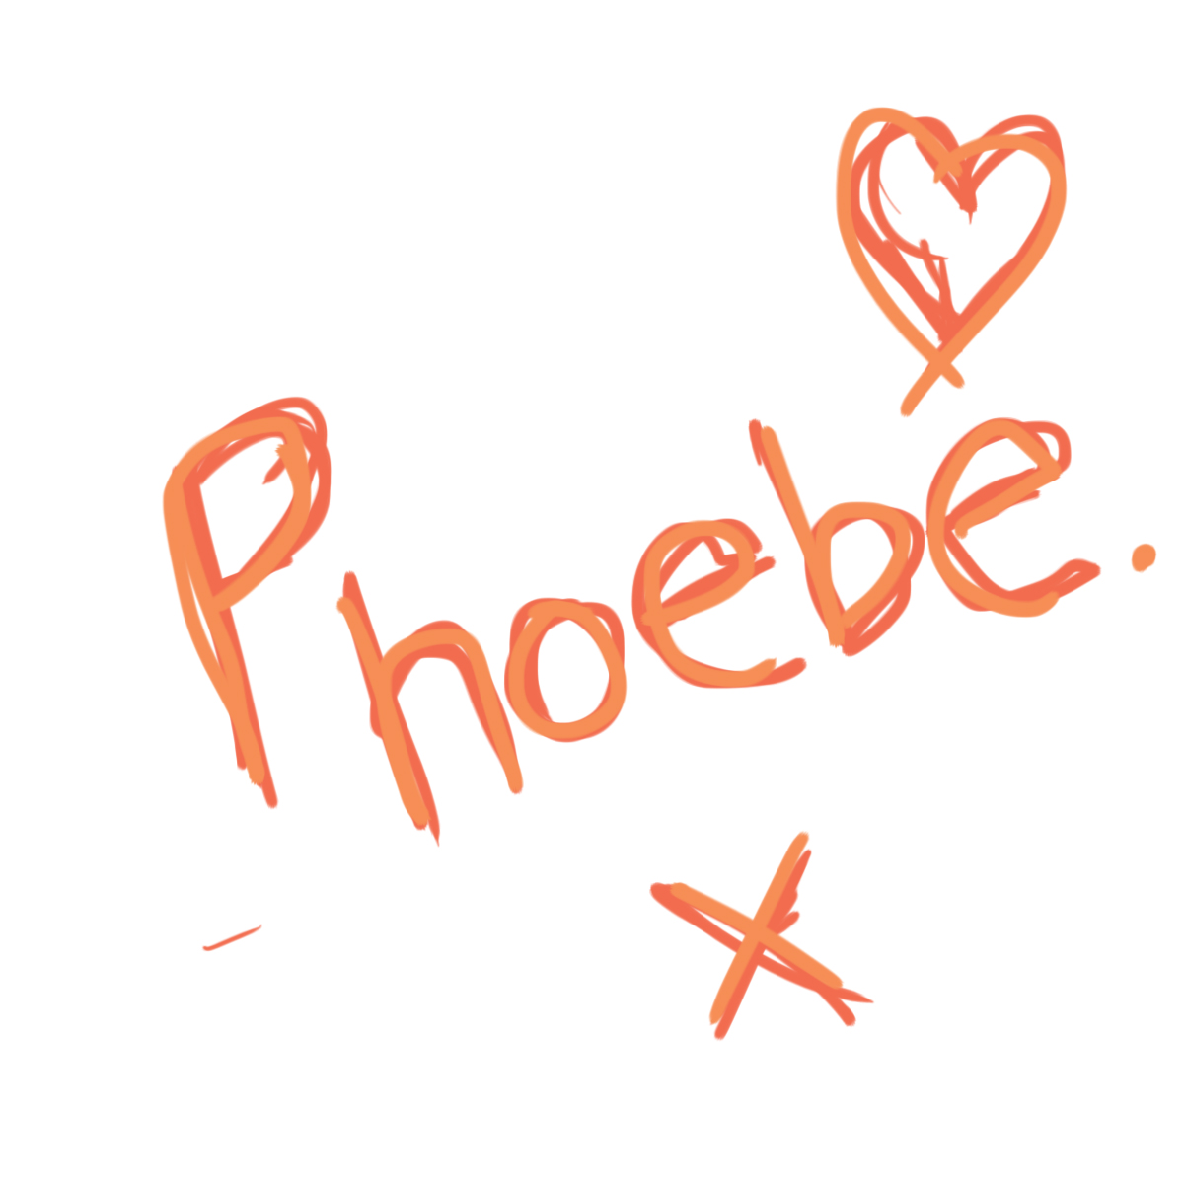
When mum saw it she was not very pleased and was about to call Phoebe, when she suddenly realised of course Phoebe was too young to write her name.

She knew who had done this. She still loved Chloe but was very disappointed that she had done something naughty.

