Come And  See  Hinduism | LOOK AND DISCOVER  Special books and Vedas and Bhagavad-Gita.  Talk about the children’s favourite books. Why they are special? Is there a book that they have had a long time that means something special to them or their family?  Read Hindu Holy Books Information*  Answer key questions:  Q What do you think the difference is between something heard and something remembered?  Q How do you think writings and stories can help people lead better lives?  Q What do you think about Krishna’s advice to Arjuna?  Key words: Vedas, Sanskrit, Upanishads  Bhagavad-Gita | LOOK AND DISCOVER  Special books and Vedas  and Bhagavad-Gita.  Following on from previous session  Activities (choose 1 from the following activities)  1.Write a story which has a message in it.  2. Research the story of the Bhagavad-Gita. (You can use the Bhagavad-Gita Research Sheet* as a template to help you.  3. Copy some Sanskrit writing (see Sanskirt example*)  Sankirt example:  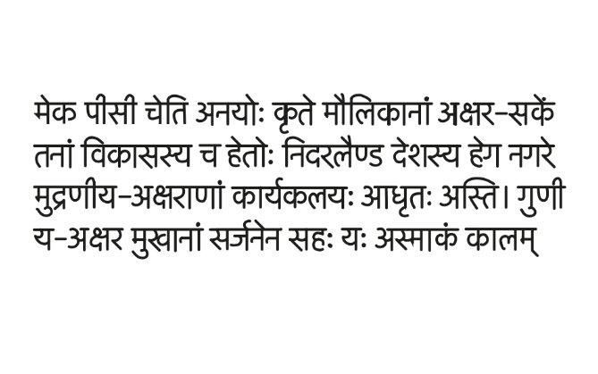 | LOOK AND DISCOVER  DISCOVER: Learning through scripture  Read “A bold Beggar PowerPoint*  Answer key questions:  Q Why did the sages refuse the beggar food?  Q What made the sages understand it was right to share their food ?  Q What did the sages need to learn from scriptures? | LOOK AND DISCOVER  DISCOVER: Learning through scripture  Follow on from previous session  Activities (choose 1 from the following activities)  1. Make a storyboard of the story. (Can use one from the Story board templates*)  2. Act out the story or make paper bags puppets to dialogue the story.  3. With the heading, ‘practise what you believe’, write an article explaining how it is important to make links between what you believe and what you do, giving examples from daily life. | DISCOVER AND RESPECT  Hindu search for truth through their stories and sacred writings guides their lives.  Read: 6 Blind Men and an Elephant  Answer key questions:  Q What did it feel like to touch part of the animal?  Q What are the situations where you only know part of the truth?  Q What helps you find out more truth?  RESPECT  Gather thoughts and have a quiet moment to reflect on what you enjoyed about the topic.  Think about and appreciate that Hindu holy books have an important message for Hindus and they help them to search for Truth and find guidance for  their lives.
* = see attached file

Hindu Holy Books Information
Hinduism does not just have one sacred book but several scriptures. Hindus read and study them as part of their worship and the contents of these books guides their lives.
There are two types of holy books, one is described as being heard. For thousands of years the contents were not written down but were learnt by heart. Later they were written down in a language called Sanskrit, which means ‘well made or put together’. The oldest is called the Vedas. The word Vedas means knowledge. It is a collection of hymns and prayers, some of which are more than 3,500 years old. They explain how to worship the gods and they give advice on life. At the end of the Vedas is the Upanishads, written about 2800 years ago. This is a collection of the teachings of the gurus (holy teachers) containing the most important of all Hindu teaching and is well known by Hindus. It is one of their most important books.
Another group of holy books are those which have been remembered and are stories told by professional story tellers. One of these writings is called the Bhagavad-Gita, or the ‘Song of the Lord’. It is well-known by Hindus. It tells the story of Krishna and the hero prince Arjuna. Their discussion teaches Hindus what is important in life, as Krishna tells Arjun that he must do his duty as a warrior without thinking about himself.
Every story has many meanings and Hindus find the Truth in their stories so they are very important.

