Spot the Pronouns and Nouns

I can use pronouns and nouns.

fish | me | railway | dog
us | them | group | it
she | homework | golf | you
hers | mine | tablecloth | ours
rabbit | sock | yours | I
1. Put a circle around all of the pronouns in this box. Underline all of the nouns.
fish | me | railway | dog
us | them | group | it
she | homework | golf | you
hers | mine | tablecloth | ours
rabbit | sock | yours | I
they | air | him | cushion
his | flower | lesson | rubber
I can use pronouns and nouns.

1. Put a circle around all of the pronouns in this box. Underline all of the nouns.
Spot the Pronouns and Nouns

fish | me  personal | railway | dog
us | them | group | it
she | homework | golf | you
hers | mine | tablecloth | ours
rabbit | sock | yours | I
they | air | him | cushion
his | flower | lesson | rubber
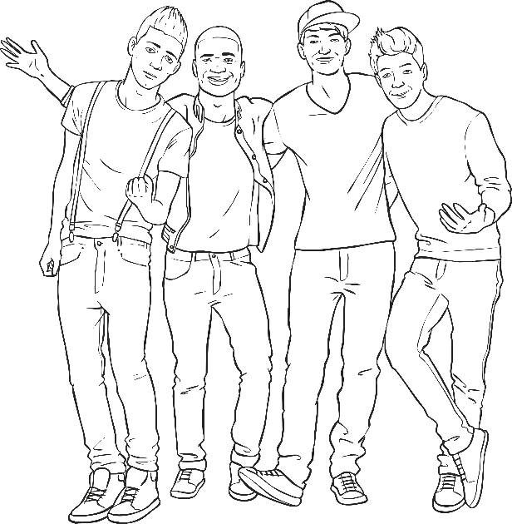
1. Put a circle around all of the pronouns in this box. Underline all of the nouns.
Spot the Pronouns and Nouns

I can use pronouns and nouns.

fish | me  personal | railway | dog
us  personal | them  personal | group | it  personal
she  personal | homework | golf | you  personal
hers  possessive | mine  possessive | tablecloth | ours  possessive
rabbit | sock | yours  possessive | I  personal
they  personal | air | him  personal | cushion
his  possessive | flower | lesson | rubber

1. Put a circle around all of the pronouns in this box. Underline all of the nouns.
2. Then, underneath each pronoun, use a coloured pencil to write what type of pronoun it is.
Use your Pronoun Definition Sheet to help you.
2. Put a circle around all of the pronouns in this box. Underline all of the nouns.
fish | me | railway | dog
us | them | group | it
she | homework | golf | you
hers | mine | tablecloth | ours
rabbit | sock | yours | I
they | air | him | cushion
his | flower | lesson | rubber

fish | me | railway | dog
us | them | group | it
she | homework | golf | you
hers | mine | tablecloth | ours
rabbit | sock | yours | I

1. Put a circle around all of the pronouns in this box. Underline all of the nouns.
Answers
Pronouns and Nouns

